

American International University-Bangladesh (AIUB)

**Department of Computer Science Faculty of Science &Technology (FST) Summer 21-22**

**Section: D Group No:02**

**PROJECT TITLE: Online Consulting Doctor**

A software Engineering project submitted

By

|  |  |  |
| --- | --- | --- |
| SL | Student Name | Student ID |
| 1 | ISLAM, ROBIUL | 19-41115-2 |
| 2 | RAHMAN, KHANDAKER MOSIUR | 19-40066-1 |
| 3 | DAS, SOUMIK | 19-40143-1 |
| 4 | RIFAT, MD. TARIF-UL-ISLAM | 19-41140-2 |
| 5 | MUIN, MUSFIQUR RAHMAN | 19-41514-3 |

1. Project proposal

### Introduction:

Disease is one of most common issues for a person’s life. If anybody is ill and wants to visit a doctor for checkup, he or she needs to visit the hospital and waits until the doctor is available. The patient also waits in a queue while getting appointment. If the doctor cancels the appointment for some emergency reason then the patient is not able to know about the cancelation of the appointment unless or until he or she visits the hospital.

For our project, we propose the development of a software by which doctors are allowed to manage their booking slots in online, patients can make their appointment to book empty slots too.

### Project objective:

Our goal will be to create a vast no. of community where there will be all the facilities to give a person his/her proper health treatment about his physical condition. It merges with the resources we have in our medical ministry with the information technology field, whereas the programming of data processing systems evolved into standardized routines and packages of enterprise resource planning (ERP) software. This linkage between medical accessories and human resources we have to be fully utilized.

### Project Description

Being hospitalized or getting treatment has always been a huge problem in our country as we have less hospital and less doctor as per we need. Sometimes we don't have the time to check door to door of every hospital to get appointment for a doctor or getting an ICU. In this such a pandemic situation where we need to stay at home for specially this consequence it is quite impossible to meet a doctor physically. Somehow we can reduce this problems there will be a huge chance to save a life. Now a days, our country is going through with such a pandemic where getting treatment has become a huge problem. That's why we want to develop a system

which can reduce such kind of problem for which we are suffering like getting appointment from a doctor or getting an ICU etc. Though we want to do something better for our patient but it will also be a good opportunity for us to grave the software market with a huge benefit. More than that, our main goal is to think about the patients. For all of the reason we want to do Online Doctor Consulting software project.

In an online call in a doctor system, a user (patient/doctor) places a request to the system for registration. The system then gets all the carrier names and their time schedules in the system server. System can verify and cancel the request if it failed to verify the user. User (patient/doctor) can login into the system through the username and password. If a user (patient) log in to the system he/she will find 3 categories. User can choose any option as his/her need. If user chooses “Online doctor”, then he/she will be able to confirm his/her appointment through system’s functionality. To confirm the appointment user must have to go through a payment procedure. After a successful payment procedure, the system will reserve user’s information as an appointee and will return a schedule for consultation via SMS. If a user (patient) chooses “Meet a doctor” he/she can give an appointment request through the system to the doctor’s chamber and from the chamber a schedule and serial number will be provided to the user via SMS. To confirm the appointment user must have to go through a payment procedure. After a successful payment the appointment will be confirmed. If a user chooses “Call in a doctor” he/she can send request to the selected doctors according to user’s area for emergency treatment. If doctor accept the request user have to go through a payment procedure. After payment system will confirm the doctor that schedule is confirmed. If a user (patient) chooses “Immediate ICU” he/she can see available ICU’s information according to his/her location. If user click on any hospital’s icon, he/she can see details information. If user chooses “Free doctor”, he/she will be able to book a slot for free by maintaining the system criteria.

If a user (doctor) log in to the system, he/she can see her profile and the consulting requests from the user. User (doctor) can update his/her profile continuously.

### Application Feature:

Here are the all features of this software:

1. Simple log in process.
2. Making profile of doctors.
3. 3 categories for visit a doctor.
4. Immediate ICU.
5. Booking an ICU.
6. Free Doctors.
7. Online Payment
8. Effort Estimation
9. SYSTEM TEST PLAN

# Process Model

The software development models are the various processes or methodologies that are being selected for the development of the project depending on the project's aims and goals. There are many development life cycle models that have been developed in order to achieve different required objectives. Our project is based on online doctor consulting and medical facilities in this pandemic situations. For our project “Online Doctor Consulting ” we choose SCRUM which is iterative process model. SCRUM is a agile process most commonly used for product development. SCRUM is a framework that is applicable in any type of software management project with aggressive deadline, any type of requirements and a degree of uniqueness. Each iteration consists of two- to four-week sprints, where each sprint's goal is to build the most important features first and come out with a potentially deliverable product.

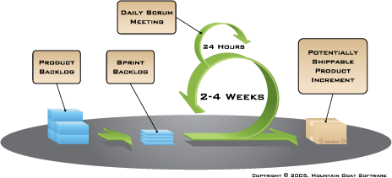

The reason behind using SCRUM method for our project is that during this pandemic situation the death and cases rate is increasing day by day, which is alarming for our country. In this situation we need emergency medical facilities and consulting hour of a doctor by online to prevent social gathering. So we have to release our software quickly as soon as possible with high quality facilities and useable software to users. Within a short time to complete our project we need to fulfill the requirements of the client with proper plan and each team members need motivation to complete their responsibilities successfully. To achieve this benefit we think that SCRUM is best.

Here are the benefits from using SCRUM are:

* 1. It can help teams complete project deliverable quickly and efficiently
  2. Large projects are divided into easily manageable sprints
  3. Works well for fast-moving development projects
  4. Fast response to changes for update new features
  5. Direct collaboration with the client
  6. Better user satisfaction and adopts feedback from them
  7. Short sprints enable changes based on feedback a lot more easily
  8. The effort of each team members are visible during daily SCRUM meeting

## Software Requirement Specifications

### Functional Requirements:

1. Software shall allow users to register for creating valid account.
2. Software shall allow users to login with Username and Password.
3. If the login successful Home page will be displayed and users can get access to the information desk for doctors appointment.
4. If login failed, a random verification code will be generated and sent to the

user’s email address by the system to further login.

1. **Create Account**
   1. The user has to create an account for access our services.
   2. First user has to create their account by user name and email. They can also directly link up with email and mobile number. Then user have to fill up their mobile number, address, date of birth, gender.
   3. If the user forgets their password or user name, they can get OTP code to recover their password by pressing the forget password option.
   4. Then shows the account will create successfully and one can enter to the homepage.
2. **Medicine**
   1. User can request their specific medicine.
   2. In emergency cases user can upload their prescription into the server for getting their valuable medicine and they can also check the availability of medicine and also know the price of medicine and they can order also.
3. **Tools**
   1. User can check the tools availability like oxygen cylinder, bp machine and stethoscope, injection, pulse oximeter, thermometers, mask and hand sanitizer, furniture, ECG product, infection control, diagnostic equipment etc.
   2. If user can find the tools, they can get their service from tools section.
4. **First Aid**
   1. User can check first aid equipment availability.
   2. They can get their service according their need.
5. **Ambulance**
   1. In emergency cases user can check the availability of ambulance and request for ambulance.
6. **Nurse**
   1. User can check the availability of nurses and emergency cases one can request for the service. In critical condition of patients one can request for the nurse in their respective place
7. **Others**
   1. In others section user can check the availability of feminine service, surgical service, baby products, medical accessories.
8. **Search**

12.11ser can search their specific items by their needed.

1. **Billing**
   1. User can check the billing system.
   2. They can also pay via online like Bikash, Rocket, Card system.
   3. They can also get their payment slip.
2. **My Account (User)**
   1. User can change their name, password, email, phone number.
   2. They can also see their history accordingly their search item.
   3. They can also check their dashboard.
3. **Doctor Appointment**
   1. User can request for the doctor appointment by their choices.
   2. They can also see the doctor availability and doctor list.
4. **Blood bank**
   1. User can see the availability of bloods by their blood group.
   2. They can also request for blood by their blood group.
5. **Health Insurance**
   1. User can check the availability of health insurance category.
   2. They can apply for their insurance from the category.
6. **Log out**
   1. User can log out from the service.

### Non-Functional Requirements:

* + 1. Design
    2. Color
    3. Secure

**Use case:**

## UI/UX Design

Online Doctor consulting

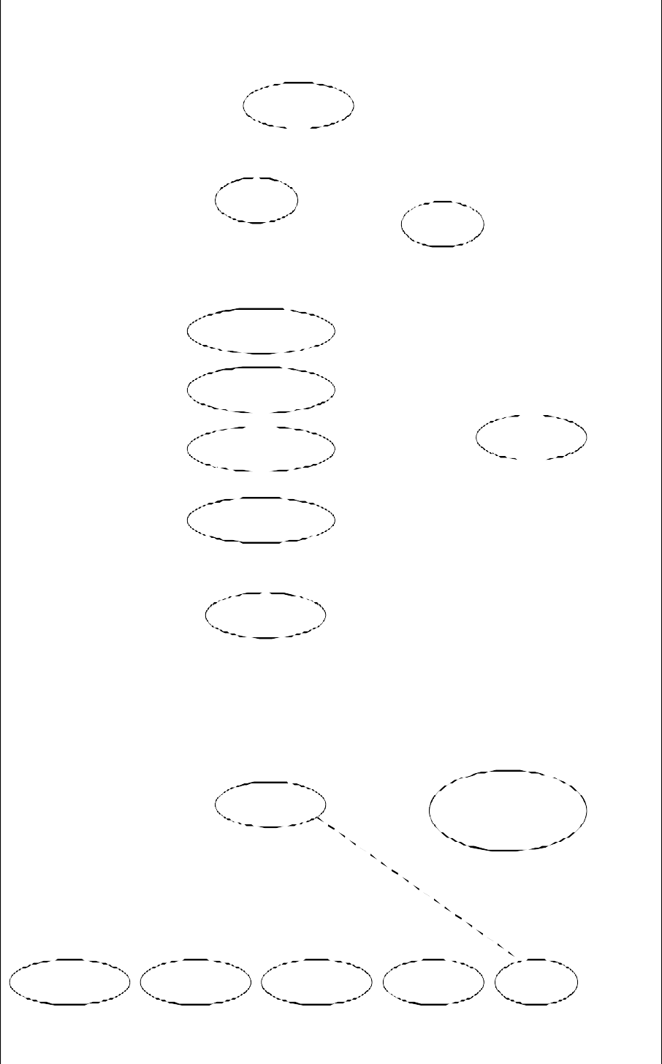

Rregistration

«extends»

«extends»

DataObject

Patient Login «extends»

Verify

«extends»

Free_Doctor

Request_Online_Doctor

Meet_Doctor

«includes»

«includes»

«includes»

«includes»

Accept/Cancel

Request_call_Doctor

System

Take_ICU_service

Doctor

Make_Payment «extends» Make_payment_reciept

«extends» «extends»«extends»

«extends» «extends»

Make_Credit_card Make_Nagad Make_Bkash Make_Rocket Cash

# Software Interfaces

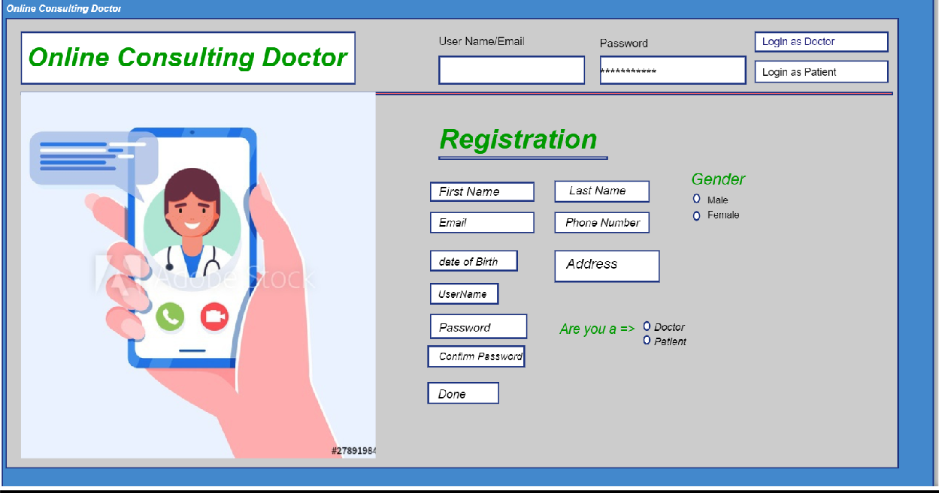

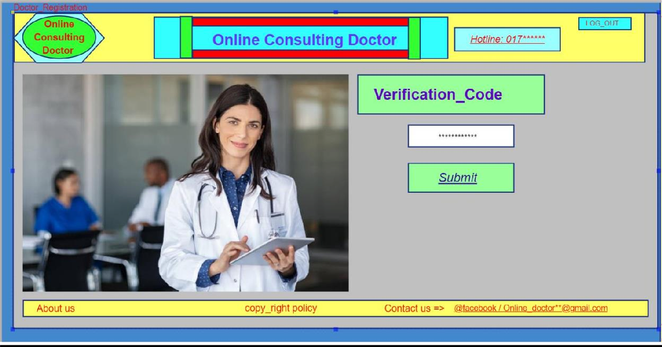

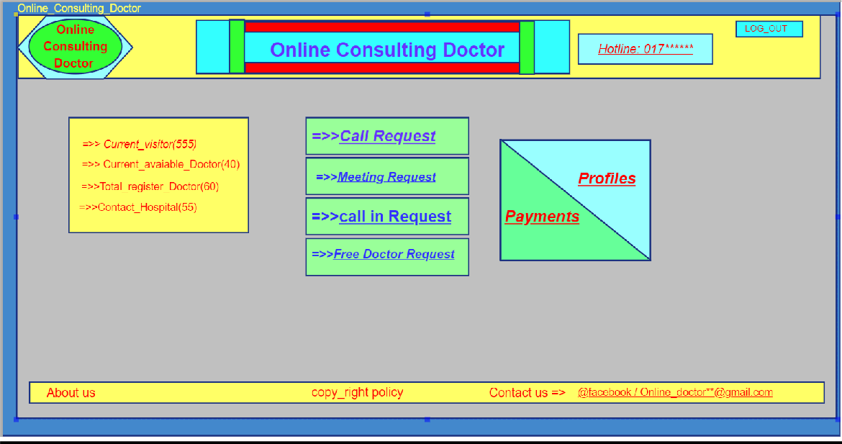

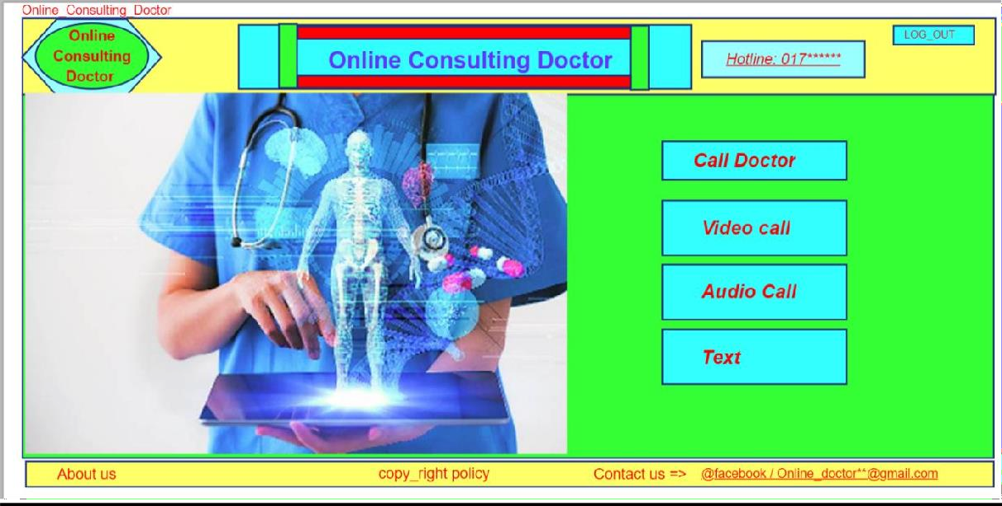

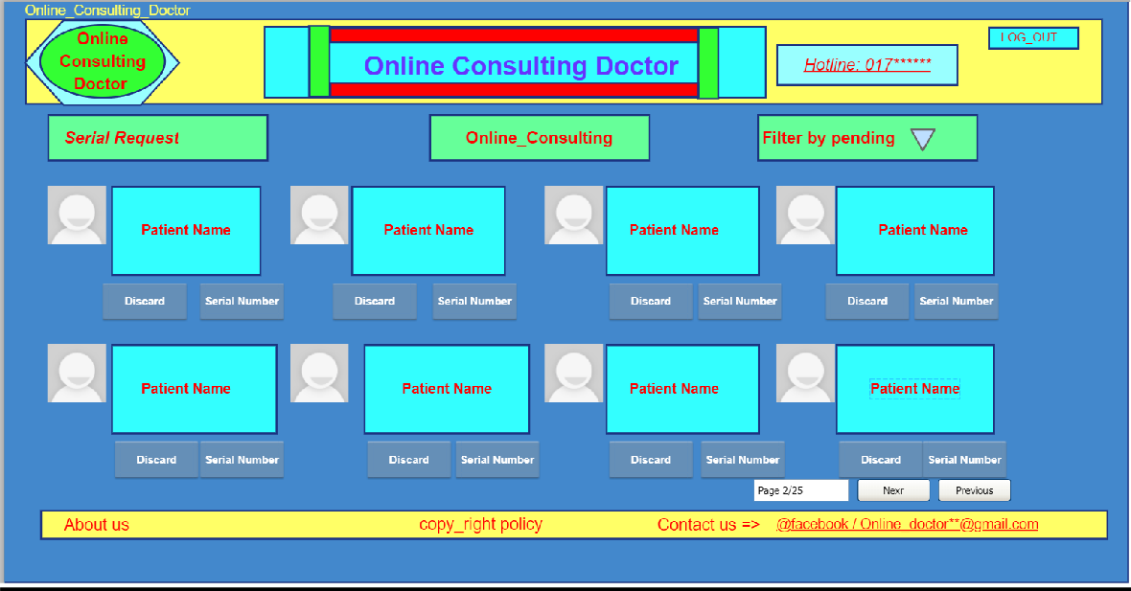

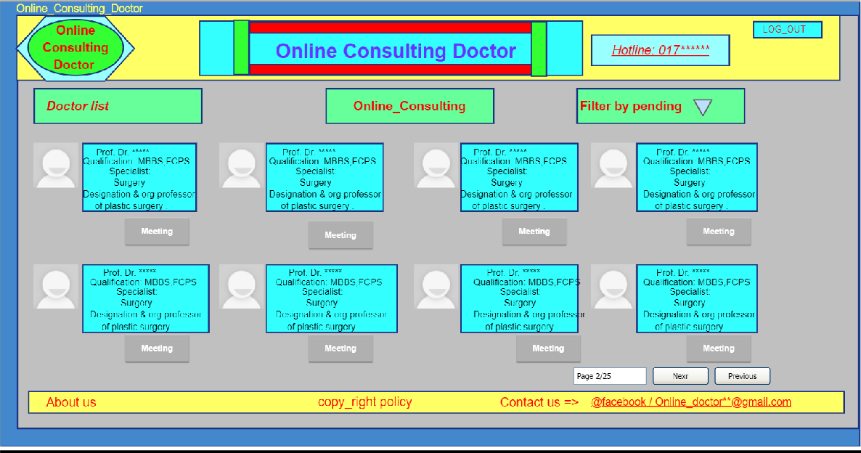

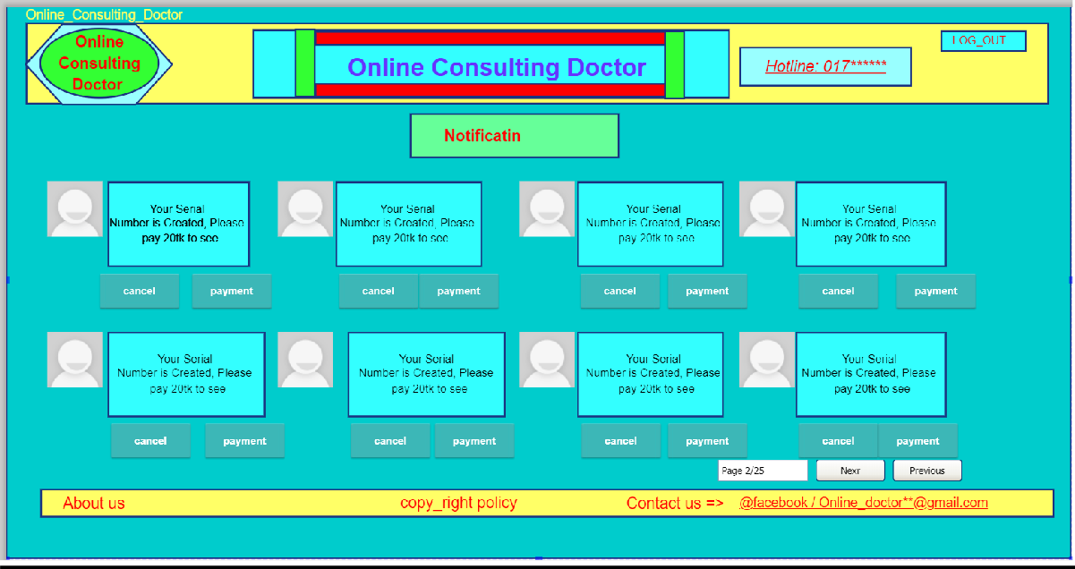

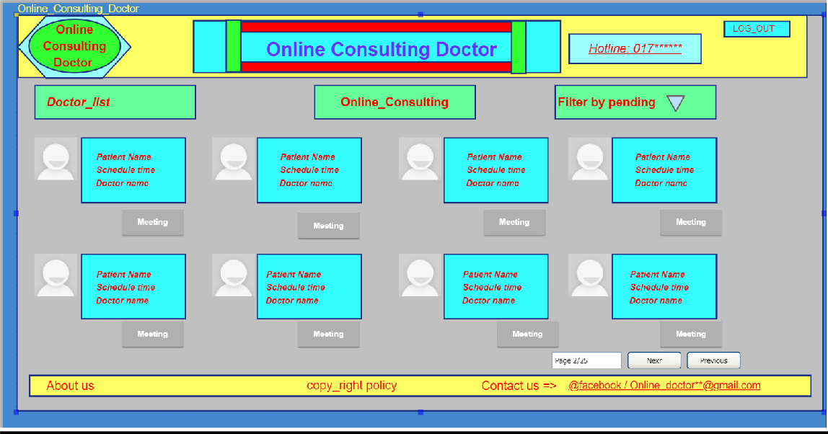

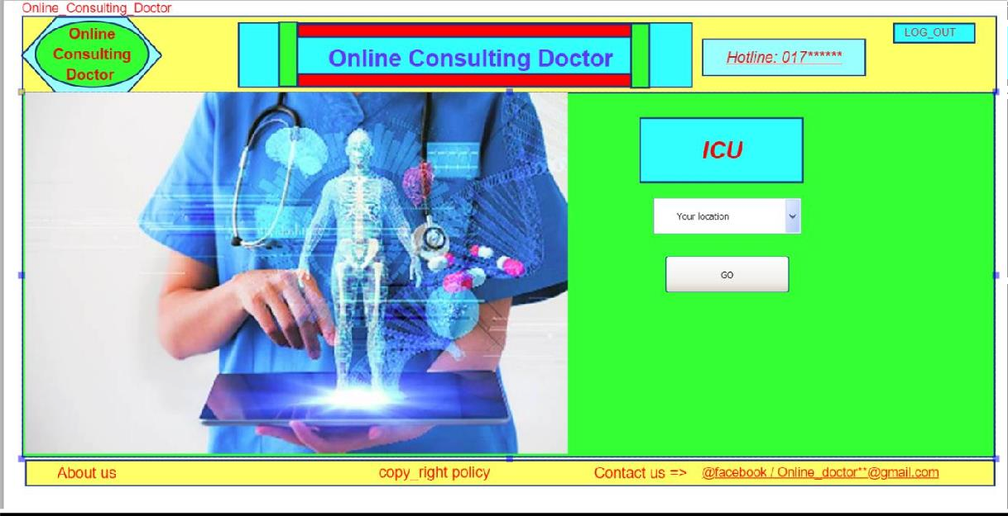

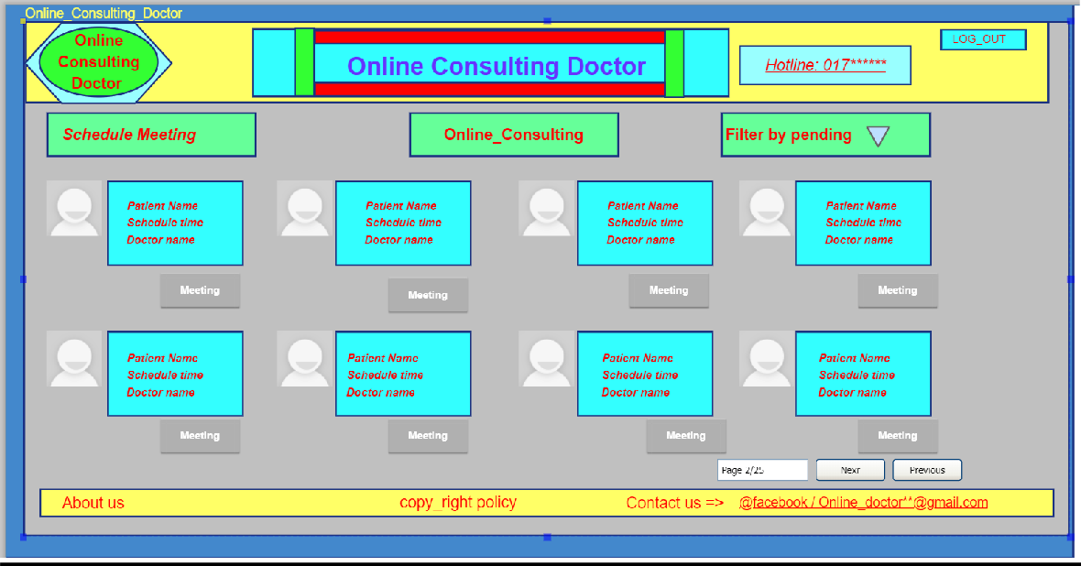

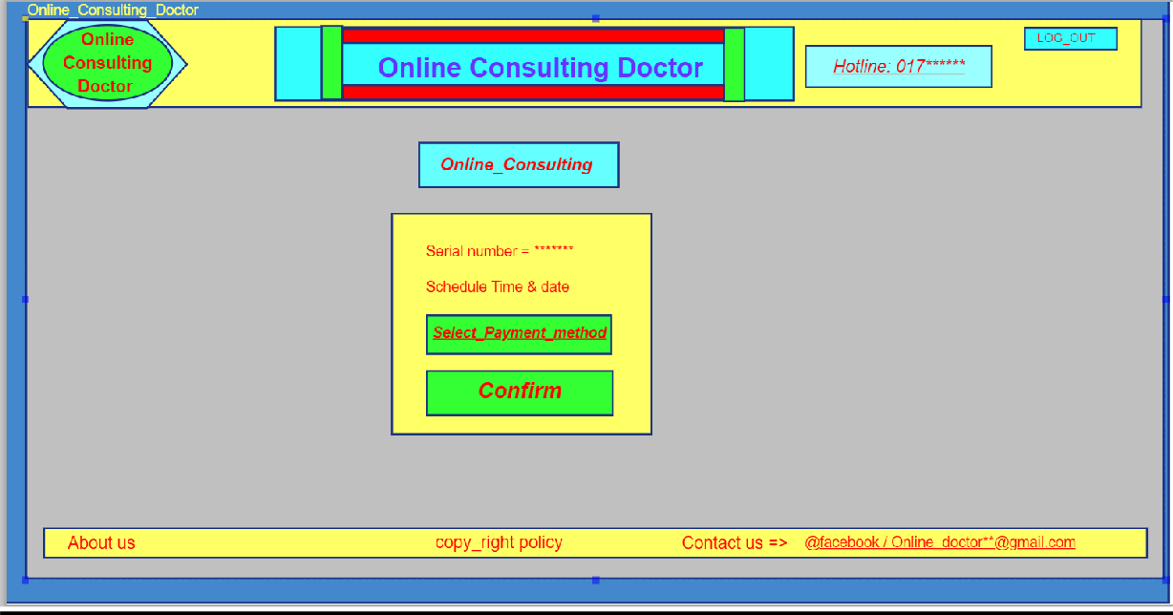

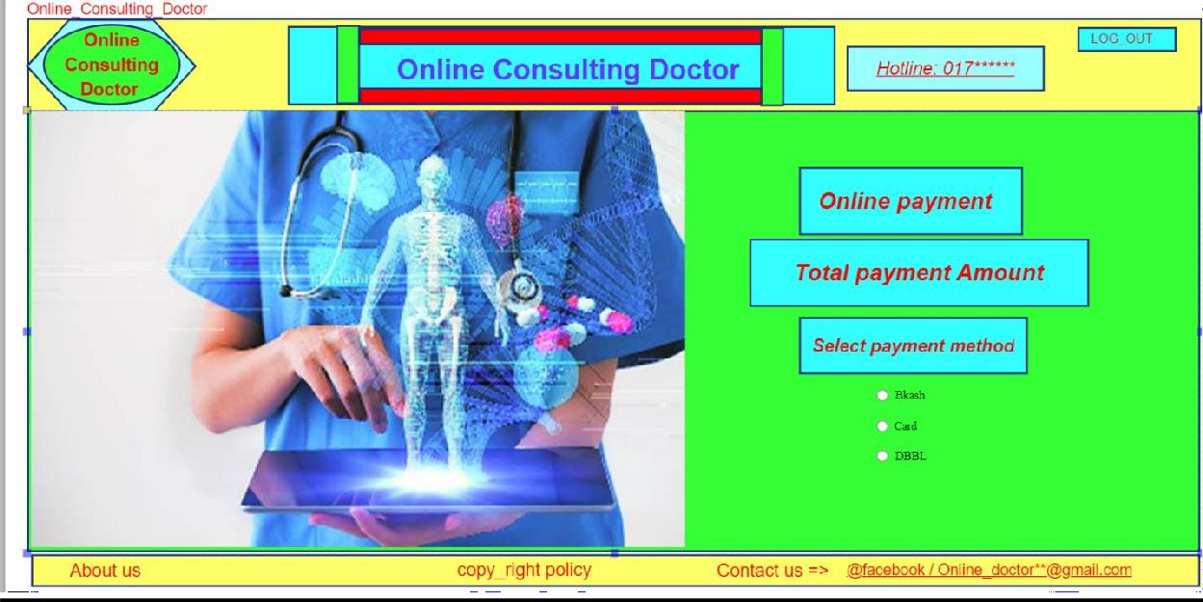

### 8.Effort Estimation

1. **- AVAILABITY**: Our application is 90% present available on weekdays between 2:00 am to 7:00 am. And at least 99.4% available on weekdays between 7:00 am to 2:00 am.

*Priority Level:* Medium *Precondition:* N/A *Cross-reference:* QA-2

1. **- PERFORMANCE:** Our application can serve 50 thousand people at a time. And our software page load time is maximum 10 sec.

*Priority Level:* Medium *Precondition:* N/A *Cross-reference:* QA-1

1. **- EFFICIENCY:** Our application is light software. It’s use at least 15% of the processor and RAM available to the application at the peak load conditions.

*Priority Level:* Medium *Precondition:* N/A *Cross-reference:* QA-2

1. **- FLEXIBILITY:** Our application can add new capabilities when it’s needed. We have development team which can able to make a new copy output available to the product, including code modifications and testing, with no more than 10 hours.

*Priority Level:* Medium *Precondition:* N/A *Cross-reference:* QA-3

1. **- INTEGRITY:** Our application Integrity requirements have no tolerance for errors. We accept online payment from our clients which can be access by only the auditor.

*Priority Level:* Medium *Precondition:* N/A *Cross-reference:* QA-6

1. **- INTEROPERABILITY:** Our application can easily exchange data or service with other system to provide one-stop services to the users.

*Priority Level:* Medium *Precondition:* N/A *Cross-reference:* QA-5

1. **- PORTABILITY:** Our application is android base software. It’s easy to transfer from one device to another or it can be downloaded from our website or play store for free.

*Priority Level:* Medium *Precondition:* N/A *Cross-reference:* QA-6

1. **- REUSABILITY:** Our application’s features functions shall be designed to be reusable at the object

code level in other application that use the similar application.

*Priority Level:* Medium *Precondition:* N/A *Cross-reference:* QA-7

1. **- RELIABILITY:** Our application is more reliable health care app than any other health care app in the market. In our test runs of the application only 4 of the 1000 runs are fails.

*Priority Level:* Medium *Precondition:* N/A *Cross-reference:* QA-8

1. **- USABILITY:** Our application is easy to use compare to others. Client can choose the default language for the app. And we use symbolic icons to the options to easy to understand for our clients.

*Priority Level:* Medium *Precondition:* N/A *Cross-reference:* QA-9

1. **- MAINTAINABILITY:** Our application is easy to maintain. We have a maintenance team which can able to modify or fix the application’s any failure within 24 labor hours.

*Priority Level:* Medium *Precondition:* N/A *Cross-reference:* QA-10

1. **- TESTABILITY:** In our application the maximum cyclomatic complexity of a module shall not exceed 20.

*Priority Level:* Medium *Precondition:* N/A *Cross-reference:* QA-11

**9. SYSTEM TEST PLAN**

